RSDS DS_CURR_TXT XTK_FF - IOBJ MD_CURR

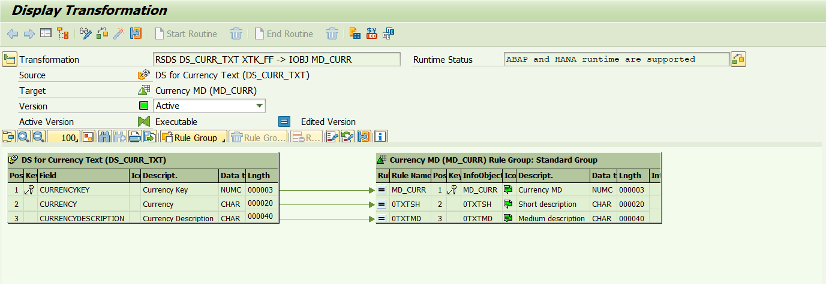

RSDS DS_CUS_MD XTK_FF - IOBJ MD_CUS

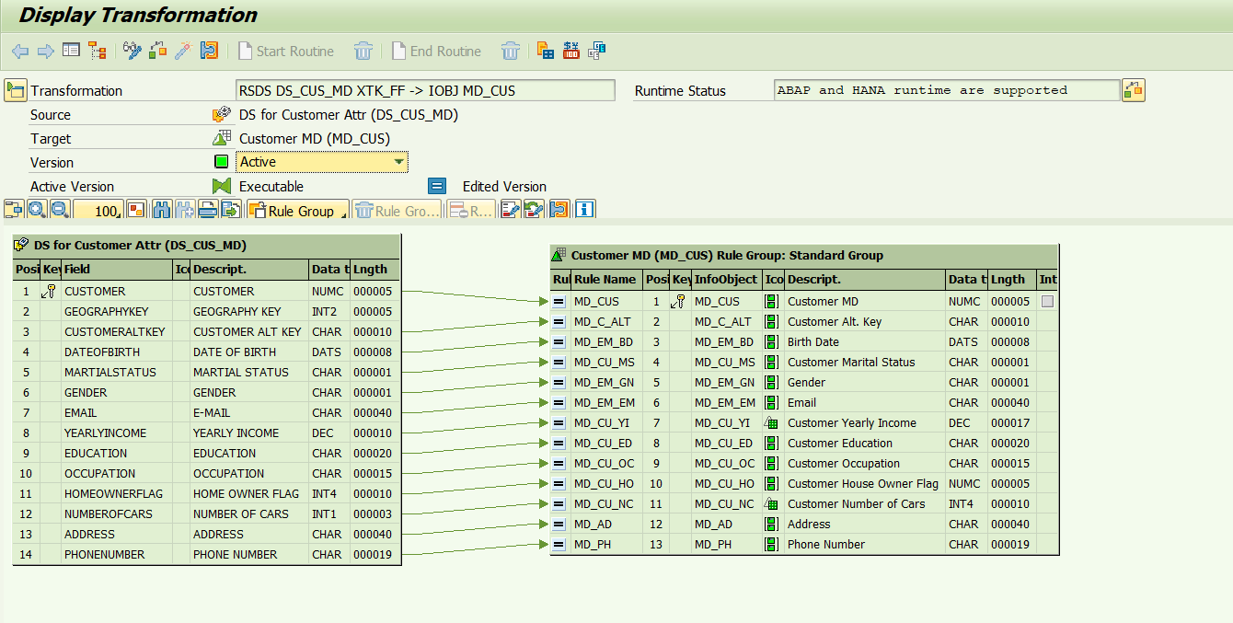

RSDS DS_CUS_TXT XTK_FF - IOBJ MD_CUS

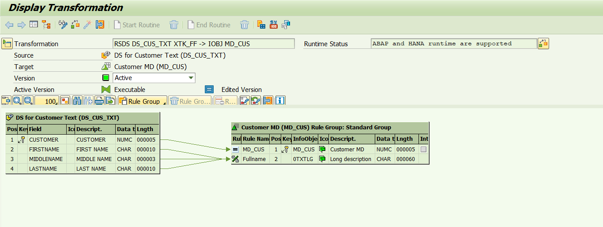

RSDS DS_DP_GR_MD XTK_FF - IOBJ MD_DP_GR

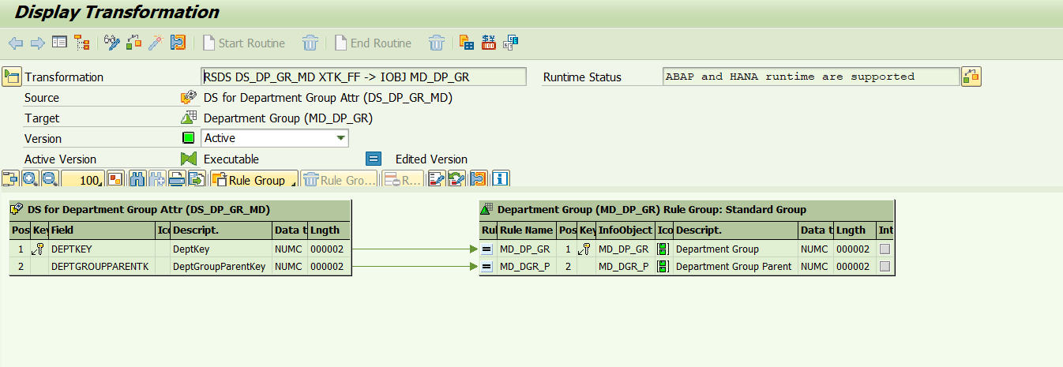

RSDS DS_DP_GR_TXT XTK_FF - IOBJ MD_DP_GR

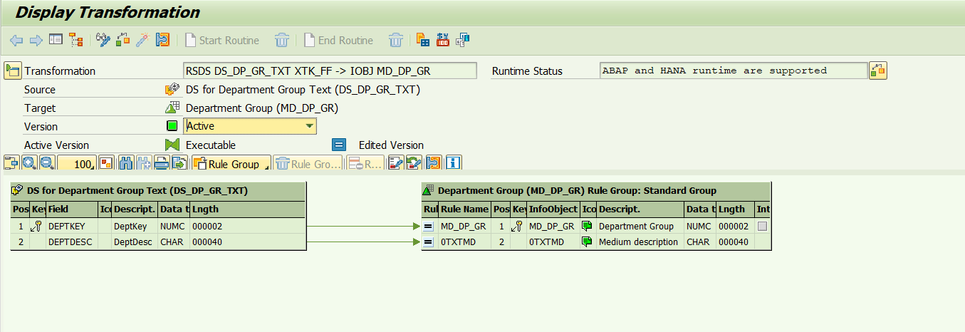

RSDS DS_EMP_MD XTK_FF - IOBJ MD_EMP

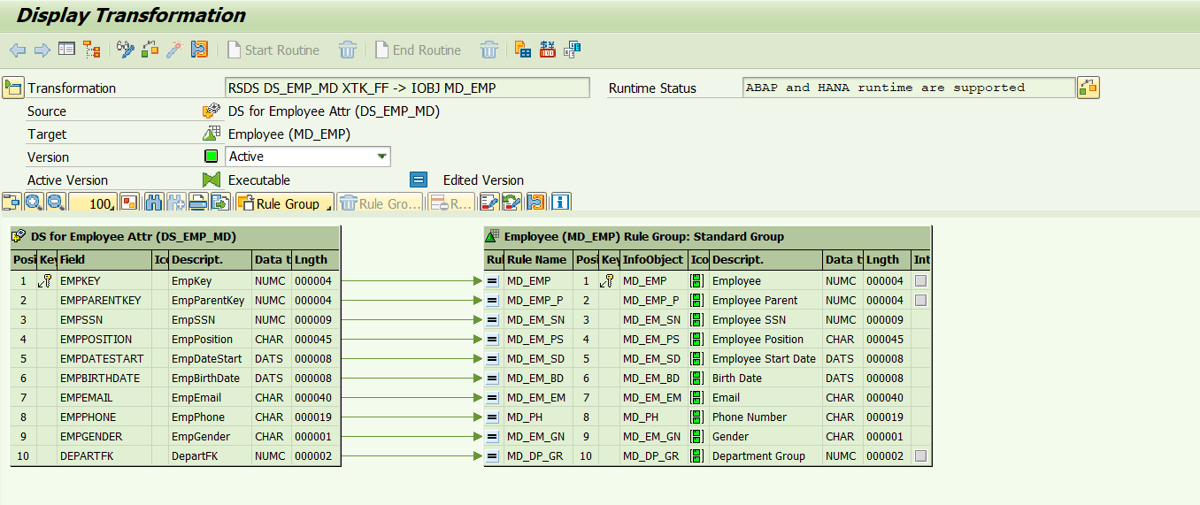

RSDS DS_EMP_TXT XTK_FF - IOBJ MD_EMP

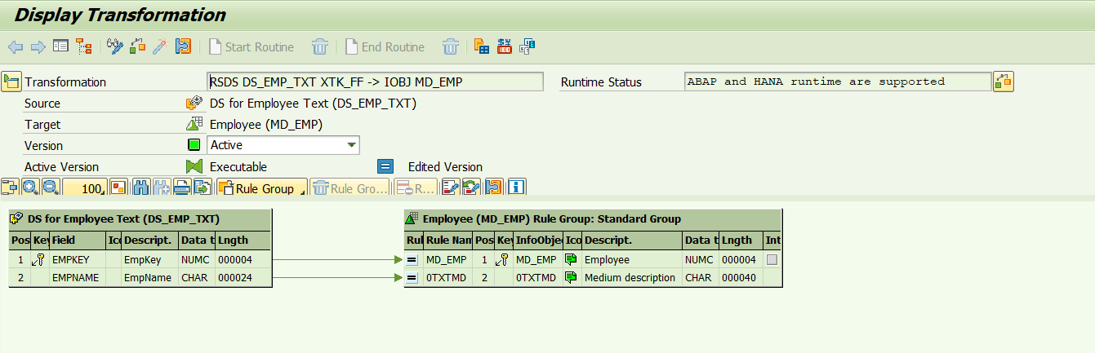

RSDS DS_PR_CG_TXT XTK_FF - IOBJ MD_PR_CG

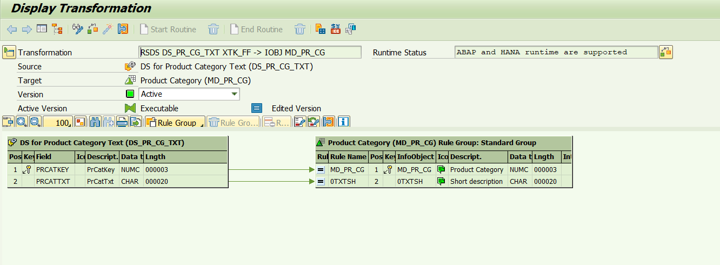

RSDS DS_PR_SC_MD XTK_FF - IOBJ MD_PR_SC

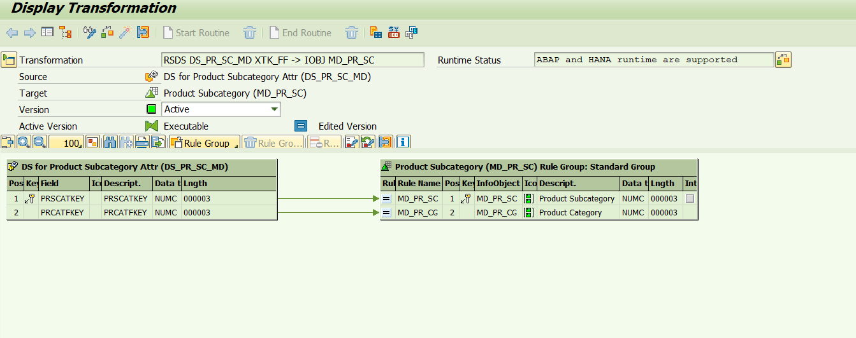

RSDS DS_PR_SC_TXT XTK_FF - IOBJ MD_PR_SC

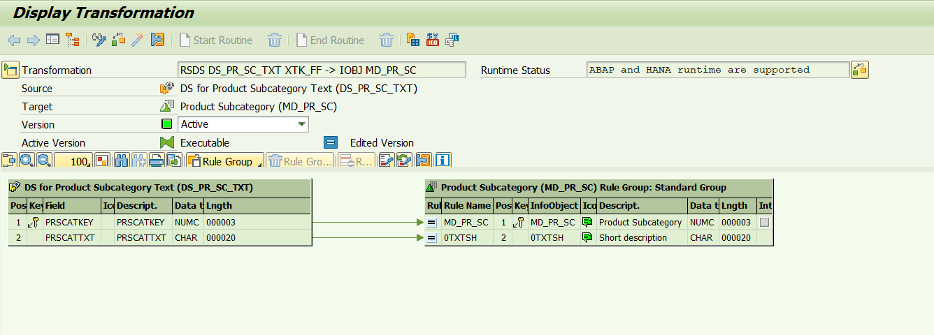

RSDS DS_PROD_MD XTK_FF - IOBJ MD_PROD

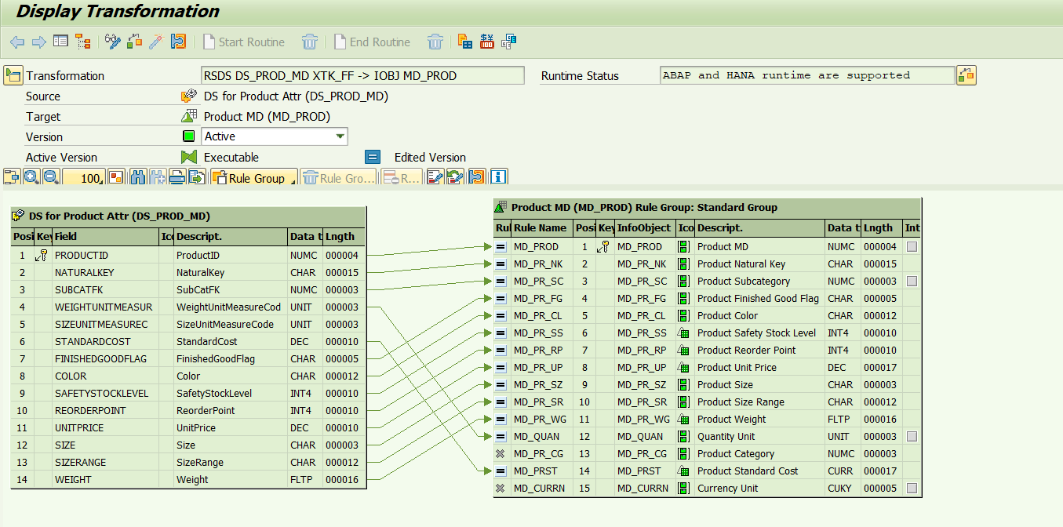

RSDS DS_PROD_TXT XTK_FF - IOBJ MD_PROD

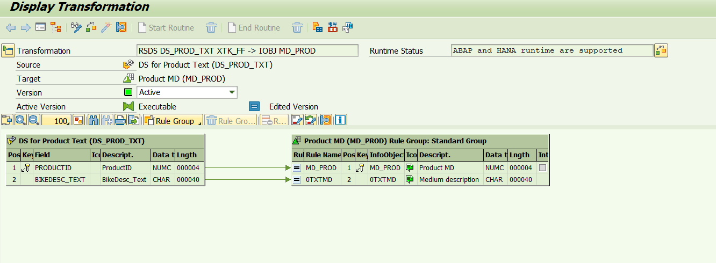

RSDS DS_PROM_MD XTK_FF - IOBJ MD_PROM

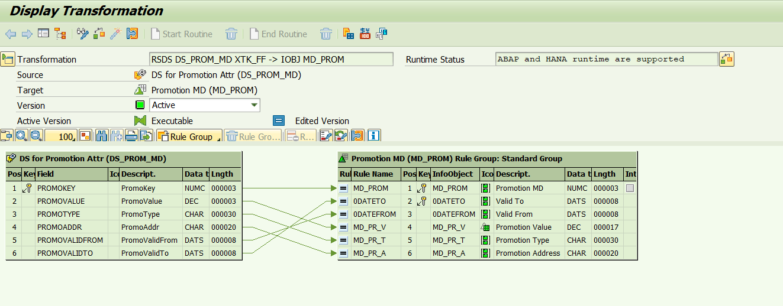

RSDS DS_PROM_TXT XTK_FF - IOBJ MD_PROM

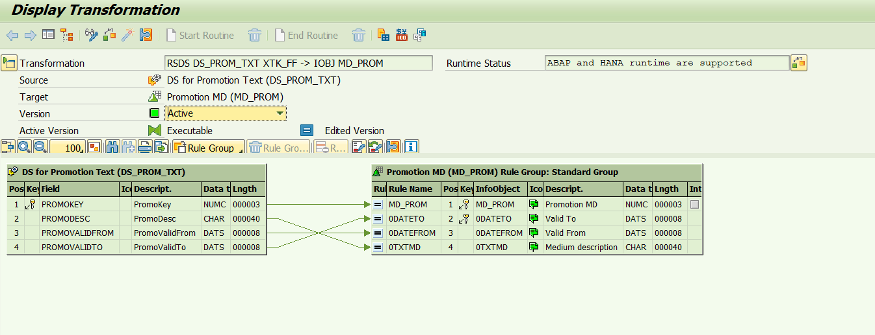

RSDS DS_RS_MD XTK_FF - IOBJ MD_RS

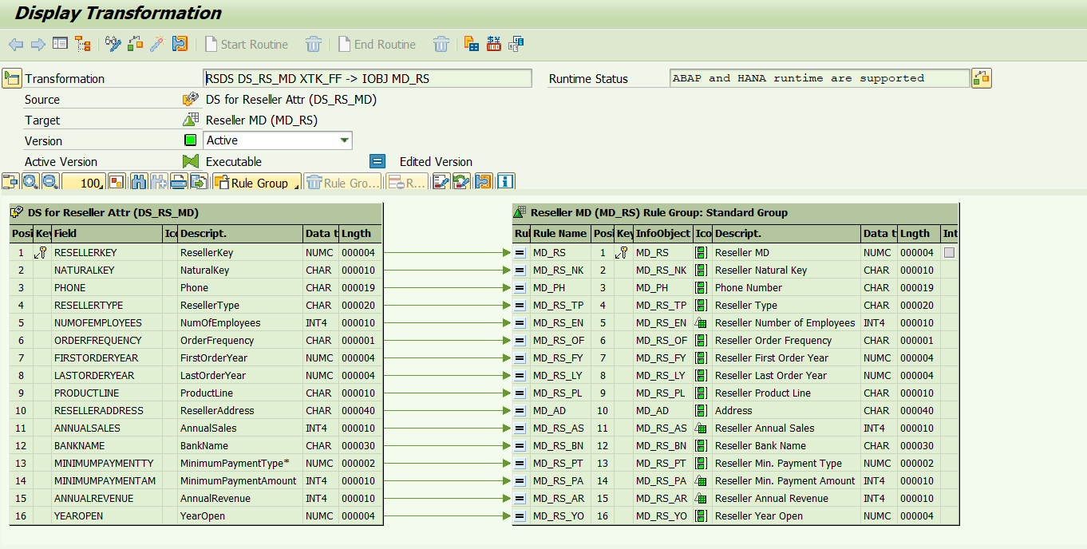

RSDS DS_RS_TXT XTK_FF - IOBJ MD_RS

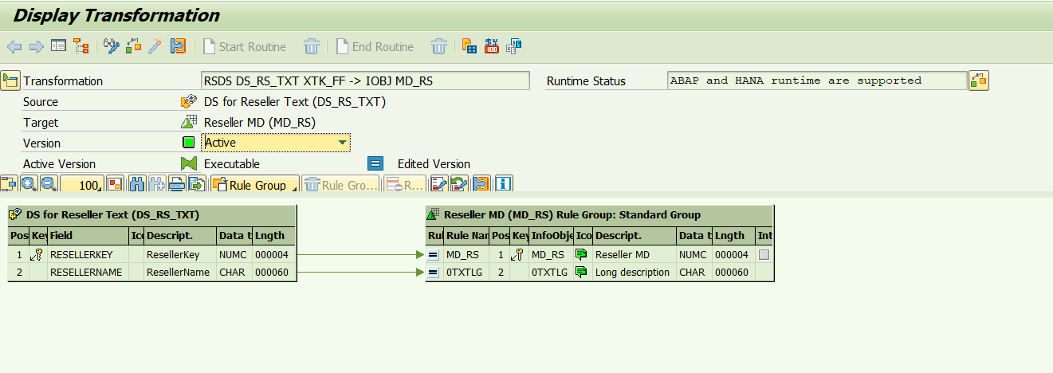

RSDS DS_S_TY_MD XTK_FF - IOBJ MD_S_TY

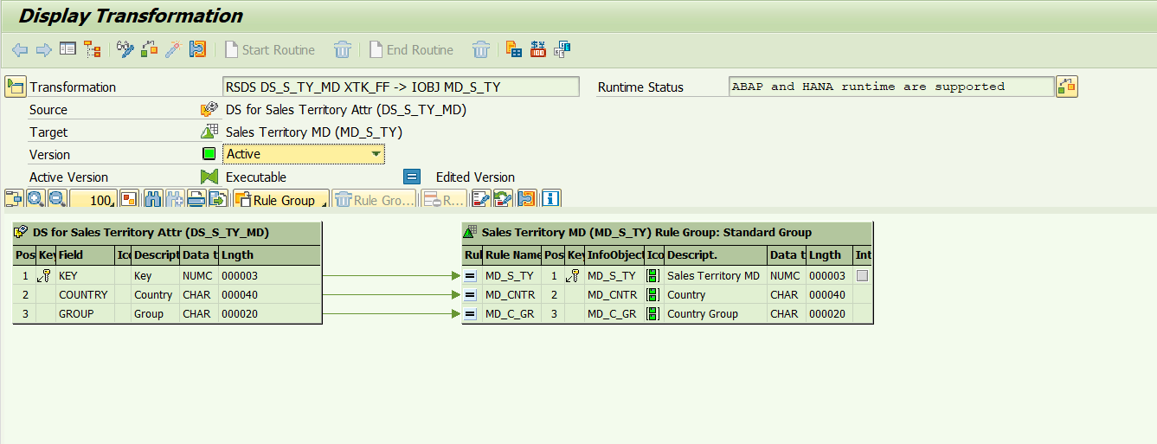

RSDS DS_S_TY_TXT XTK_FF - IOBJ MD_S_TY

